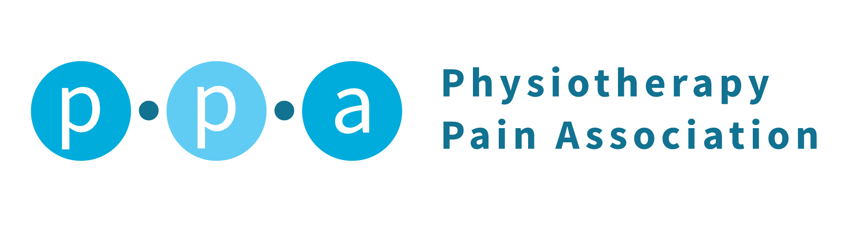
Innovation Collaboration Inclusion

Mission statement

The Physiotherapy Pain Association (PPA) champions physiotherapists working across all specialities in contemporary physiotherapy practice, drawing on biopsychosocial and narrative approaches to support people living with pain.

Objectives:

- To value the experiences of those living with pain and to work with the voice of the patient in the development of PPA strategies and training
- To develop a strategy that effectively communicates the value and vision of the PPA to our members
- To advocate for those living in pain through providing inclusive, high quality pain services, support networks and representation
- To support quality training, education and peer-supervision for members of the PPA to facilitate reflection, clinical development, innovation and shared learning
- To raise the profile of the PPA in fields of pain management, public health awareness and relevant others and to act as stakeholders, providing feedback on National guidelines and organisational documents
- To provide a community of practice to share knowledge and experience in order to improve outcomes for people living with pain
- To explore the development of technology likely to affect the delivery of pain management healthcare with members and partners.
- To include the student and early career therapists voice in the PPA, to consult about career development and learning experiences.
- To support evidence-based research, clinical expertise, cutting edge pain therapy options and multidisciplinary treatment that aims to enhance physical and psychological well- being
- To celebrate diversity and promote pain management for patients and physiotherapists regardless of age, disability, gender (including gender reassignment), marriage and civil partnership status, pregnancy/maternity, race, religion or belief, sex, and sexual orientation.

Ratified by PPA Exec Committee, February 9th 2021.
Review date at PPA AGM 2021-2022

