Friday 10th October 2014. Louis Gifford - Head, Heart and Hands.

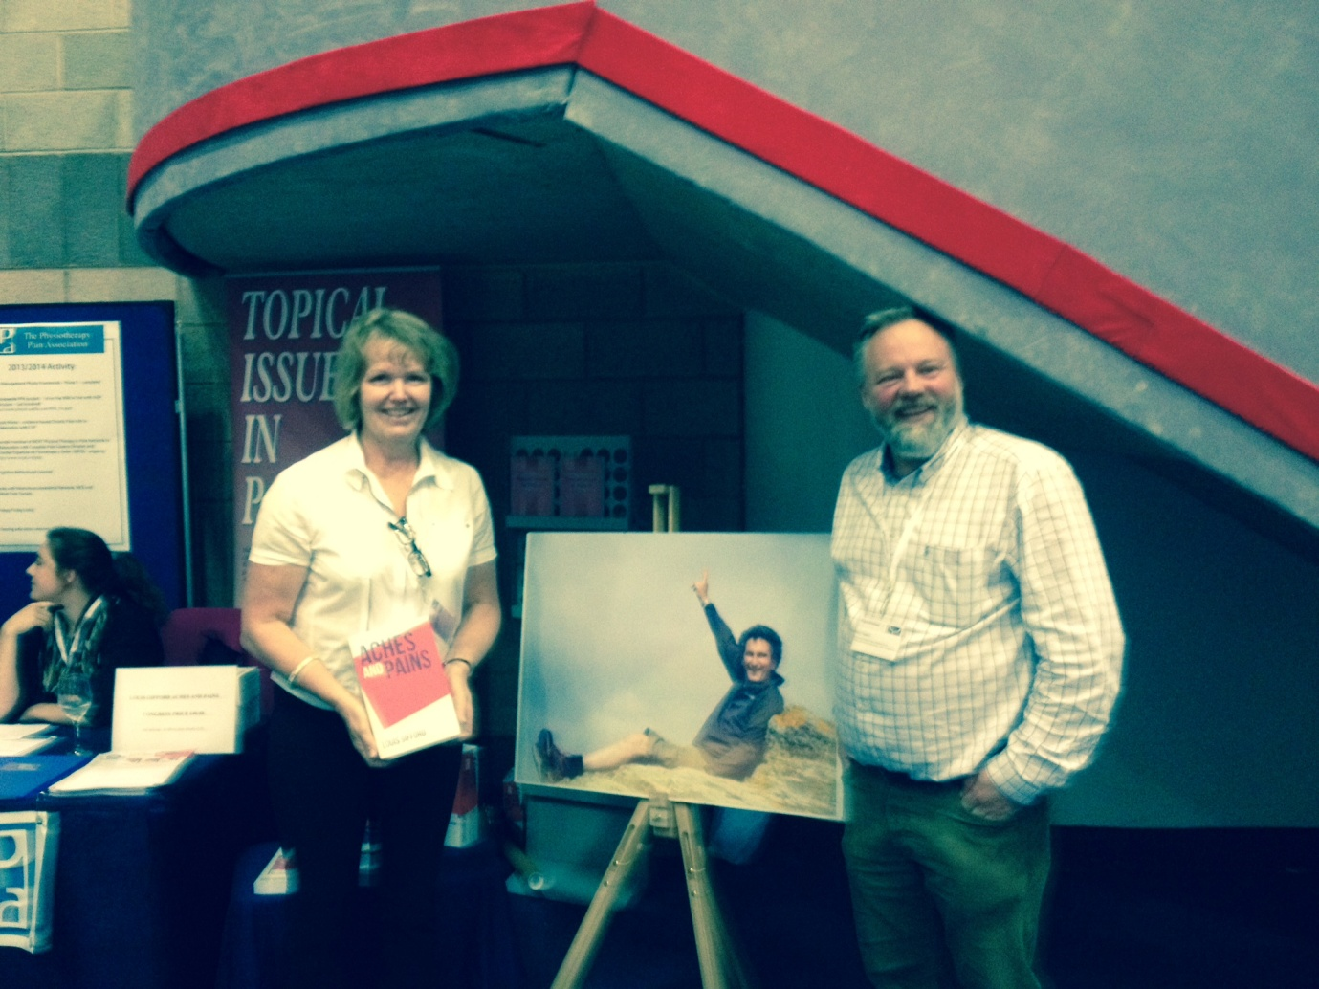
From left to right – Philippa Tindle, Louis Gifford and Mick Thacker
Earlier in the year Physiotherapists around the world were saddened to hear of Louis’ death from prostate cancer. As a celebration of Louis’ life and work it was decided to dedicate a session to him at this years Physiotherapy UK conference in Birmingham . The session was chaired by close friend and colleague Heather Muncey, founder member of the PPA, with presentations from buddies and intellectual sparring partners Prof Emeritus Paul Watson and Dr Mick Thacker. A packed room 1 at the Birmingham ICC eagerly awaited the lecture called Louis Gifford – Head, Heart and Hands.
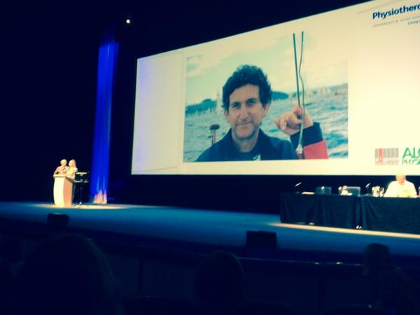
Heather Muncey and Paul Watson take the stand
Heather started the session with a thoughtful introduction welcoming and thanking everybody for coming. As Philippa, Louis’ wife, followed on there was a great feeling of warmth from the audience as she said Louis would have been pleased and humbled by the event today.

Doc, De Loreans and Fruitloopery!
Paul then took to the stage and took us on a ride in his de Lorean and proceeded to cast his critical eye over the recent history of Physiotherapy and casting his other eye to the future. He recalled the Clegg Report, published in 1979, on rates of pay in the NHS (inflation was 20%!) which stated that ‘Physiotherapy had no body of evidence’ – this provoked uproar at the time and he strongly stated that isn’t the case now!
Paul reminded us that back in the 70’s pain ‘treatments’ were PSWD and traction; the 80’s saw the rise of the ‘machines’ and mobilisations; the 90’s manual therapy, biopsychosocial model, yellow flags and muscle imbalance. When he was doing his EMG research Paul found the biggest influence on his results was a patient’s fear of movement! ( Back in 1979 pain was simple!). In 2014 we know it to be more complex including, peripheral and central sensitisation, neurodegeneration, neuroplasticity, the hypothalamic pituitary axis, cognitions and more. He went on to state that changes in genetic transcription could be influenced by catastrophisation, poor social environments and perceived social injustice.
Paul then went on to train his sights on ‘fruitloopery’ in the profession and challenged many of the alternative treatments that are provided by some Physiotherapists. To identify a treatment as fruitloopery he suggested that if it contained the words ‘energy’, ‘biodynamic’ or ‘quantum’ then it probably qualifies. He went on to conclude that neither ‘misalignments’ or ‘imbalances’ help us understand pain so why go looking for and treating them?
Paul encouraged a focus on evidence based care and evidence based reasoning and rationale for the interventions we deliver. And warned against the association of the profession with pseudoscientific approaches which lack solid theoretical foundations and scientifically testable reasoning.
What of the future? Paul thinks the current direction is about further individualising treatment based on screening of biopsychosocial factors and integration of science and evidence.
Mick then took the stand. He was visibly moved and brutally honest about how he was feeling.
Mick started off by saying that Louis was always better looking, funnier and got more recognition than himself! He went on to present a mix of key points from working with Louis but also some very fond memories too.
He echoed some of Paul’s session where he reiterated how important the Mature Organism Model had been and how relevant it still is – in fact he thinks it is the most important model for pain in Physiotherapy. He reminded everybody it was first printed in Physiotherapy and the Topical Issues in Pain 1 in 1998! He then presented a development of the MOM and how society and culture affect the brain in a reciprocal fashion resulting in pain as an embodiment of suffering within the person (Jolly and Thacker 2012).
Mick went on to describe how Louis always developed his own knowledge and practice by reaching out to other professions – he pushed his own personal comfort zone – and we should too. This continued even up until earlier this year when Louis and Mick were skyping each other and discussing epigenetics and pain! Indeed three of Louis’ most interesting recent reads had included Alva Noe ‘Out of our Heads’, Nessa Carey ‘The Epigenetics Revolution’ and Eva Jablonka ‘Evolution in 4 Dimensions’.
The session ended with a wide range of questions from the floor.
Q: How good are we at getting the public to understand pain?
A: Paul replied that Louis had often thought that getting the BBC to make a documentary with Attenbourough on pain would do the trick!
Q: From Catherine Pope: Has placebo been underused?
A: Paul stated that we understood the physiology but had queries around the ethics. He thinks part of the problem is from the name ‘I Please’. He went on to suggest that it is more getting the best therapeutic result on an individual basis.
Q: Does the CSP have a role in evidence based training?
A: PW – CPD should only be approved if evidence based – he stated that alternative medicine is an embarrassment to the profession. MT went on to state that only 4 HEI’s had pain curriculum that met the IASP core curriculum.
Q: People say they feel better with reiki – are we missing a trick?
A: PW – answer already covered in the placebo answer.
Q: Should we dumb down pain ed?
A: Thacker and Watson – NO – but be authentic – find your own words.

This was a fine and fitting tribute to Louis. His passion for living, enquiry and understanding came through Philippa, Heather, Paul and Mick today. Thank you all.

