It is very easy to add captions and subtitles to all English speaking videos. For anyone doing this for the first time please find some instructions below:

Hover your censor over the video so the command line appears

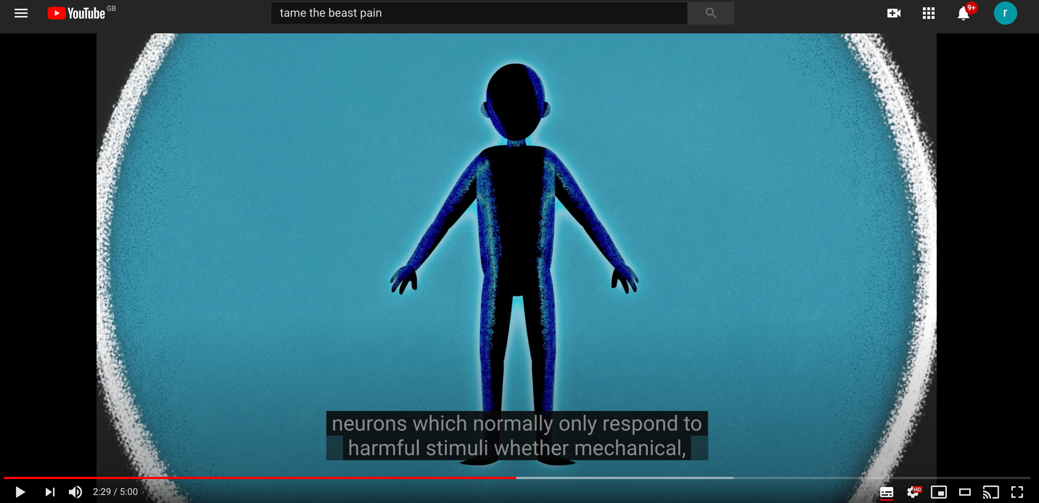
Blue arrow:

This is the settings command
Red arrow:

This is the caption and subtitles command

First by clicking on the red arrow (CC command) closed captions/subtitles appear. They are usually in English. You can skip that step and go also directly from settings as below.

Then by clicking on the blue arrow 2 different things can happen:

- You get a command box as bellow

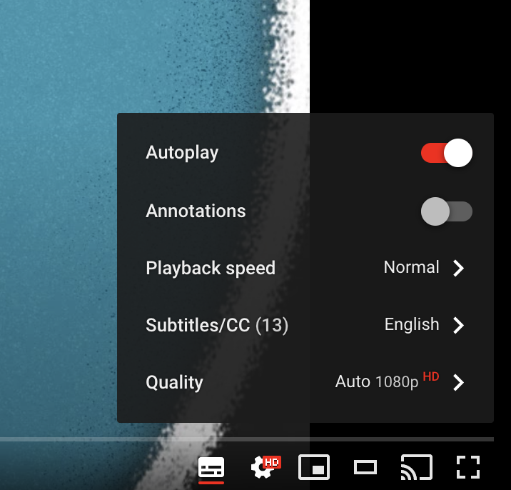
Subtitles can be turned on from here. By clicking on the arrow next to English a drop down list of all the available languages for this video will appear. By clicking on the language of your choice from the drop down list the subtitles will automatically change for example from English to Greek.

This means that subtitles are already set for the video as in the case of this example of Tame the Beast – It's time to rethink persistent pain.

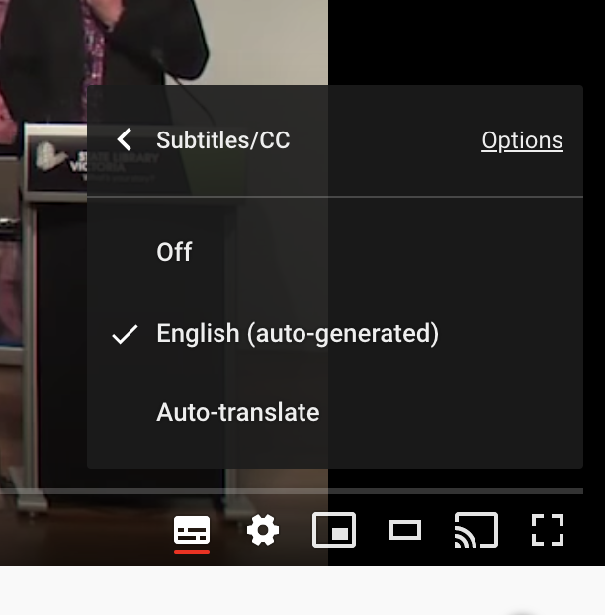
- Some videos, as in this example of Treating Pain Using the Brain - David Butler (Musculoskeletal Australia) have not been already translated so by clicking on the arrow as on the example with Tame the Beast the command box bellow will appear instead of a language drop down list. However, by clicking on Auto-translate command then a drop down list of all available automated translation languages will appear. In this way you can again change the subtitles from English to you language of choice. These subtitles will be a bit more clumsy of course, a bit like google translate.
By clicking on Auto-translate a drop down list of all the available languages in automated translation (like Google translate) will appear. You can again change the subtitles from English to the language of your choice by clicking on one of them.

