This is a Data Protection risk assessment tool that should be completed to document changes made to working practice in light of the Covid-19 pandemic.
Change Title: | Using Zoom for Psychological Consultations with Patients in cases where AttendAnywhere is not suitable | Date:
Senior Responsible  Owner (SRO): | Name:
 | Email:
Change Manager: | Name:
 | Email:
List any external organisation involved: | Zoom
Change Description: (what is the new change being implemented?)
Currently clinical psychologists and psychological practitioners hold individual, couple or group psychological interventions with patients, relatives or their care-givers face to face. Due to the Covid19 outbreak, these meetings can no longer be held face to face.

In some instances, a new virtual group intervention would allow us to respond in a way which is more appropriate than individual therapy, providing support to a greater number of patients and relatives than is otherwise possible, and responding to a changed psychological need. It would also alleviate some of the increased burden on our medical colleagues and teams.

The lack of an appropriate virtual platform can result in patients not having access to psychological support that they may require, or practitioners not being able to respond appropriately to changed needs of those we support.

The Trust’s preferred video conferencing tools are Attend Anywhere for clinician to patient contact and MS Teams for staff contact.

This change involves using the Zoom video conference platform to host psychological interventions for the duration of the Covid19 outbreak, instead of holding them face to face with patients. Zoom would only be used in cases where it is not possible to use Attend Anywhere.

There are x Psychologists in the Trust, who supervise,manage or work with a small number of other psychological practitioners and other clinical and non-clinical staff. Most practitioners, most of the time, will be able to use AA. A small number may request to use zoom, and its use will be limited to those occasions where the psychological/multi-disciplinary intervention cannot be provided via the current platform and is judged to be professionally and clinically appropriate to the changed circumstances and psychological need. Sessions will not be recorded by the host, and cannot be recorded by any participant.

Zoom’s Privacy Policy: https://zoom.us/privacy

The use of Microsft Teams has been considered, However:
- x has been informed that Microsoft Teams is not suitable for communicating with Patients.
- Zoom is much more straightforward for patients to set up.

Version Control
Version Number: | Date: | Comment:
1

Section 1

Number | Assessment Questions | Yes | No | Response (please add a response for all  questions answered ‘Yes’)
1 | Does this change involve information about  people? | Yes |  | The clinician will record the Participant’s email address on hospital records.  The Participant will be sent an email with a link to join the zoom meeting.  Given this there is no need for Zoom to record any identifiable information about the Participant in order for them to take part in the session.  Zoom will collect information about the Participant’s IP address and device.  If the participant has chosen to create a Zoom account for other reasons then Zoom would record Name, Email Address and in some instances Postal Address  The meeting host will not allow recording by any Participants, so that no audio-visual data is retained by Zoom.  No more information will be visible to participants than would normally be available when attending physical group sessions.  Further information on data collection and processing by Zoom can be found here and on Zoom’s privacy policy (above):  https://zoom.us/docs/en-us/privacy-and-security.html?zcid=3747&creative=431306240816&keyword=zoom%20security&matchtype=e&network=g&device=c&gclid=CjwKCAjw1v_0BRAkEiwALFkj5nNzo8CF9V2VmV5SZyydQZie_E0VRls_jKVkK-FklFOQayYPZ1AWYxoChBQQAvD_BwE
2 | If this change does involve information about  people - can the person be identified? | Yes |  | The individuals using zoom can also be identified by the demographic information if they choose to make a Zoom account.  However, the creation of an account is not necessary for participants to take part in these sessions.
3 | Can the information be pseudonymised or  anonymised in any way? |  | No | The ability to identify the patient is necessary for the purposes of patient care.
4 | Will information about individuals be disclosed to  organisations or people who have not previously  received it? |  | No | Patient identifiable information will not be stored by Zoom unless the Participant creates an account.  The meeting host will not allow recording, so that no audio-visual data will be recorded by Zoom.
5 | Are there any contracts or information sharing agreements in place to support the implementation of this change? |  | No

If you have answered ‘yes’ to any of the questions in Section 1, please continue to Section 2.
If not, go straight to Section 3.
Section 2
Number | Assessment Questions | Yes | No | Response
6 | Who is the subject of the information? |  |  | Patients attending Clinical Psychology meetings
7 | What type of data is being processed?  (highlight in red all that apply) |  |  | Name Gender Date of Birth  Ethnicity NHS Number Hospital Number  Address Post Code Email  GP Religion Sexual Orientation  Political Opinion Trade Union Job Title  Next of Kin Medical History Genetic/ Biometric  Audio Recording Visual Recording National Insurance Number  No data is recorded unless the participant makes an account with Zoom. All other information that is processed by the clinician would have been processed at a face to face meeting.
8 | What purpose does the collection of data serve? |  |  | Patient Care
9 | What is the legal basis for processing this data? |  |  | GDPR Art 6(1) (e) Art 9(2)(h)  Duty of confidentiality – Implied consent
10 | Does the change apply new or additional information technologies that have potential for privacy intrusion? If yes, provide further information. | Yes |  | This change involves the introduction of the Zoom video conferencing platform.
11 | Are there any existing data protection risks that will  not be mitigated by this change? If yes,  provide further information. |  | No
12 | Does the change involve new or changed  data collection practices? If yes, provide details. | Yes |  | Data will still be collected in the same way by the clinician but it will be done over the Zoom platform instead of face to face. Recording will be disabled by the clinician hosting the meeting so that this data is not stored by Zoom.
13 | Does the change involve new or changed  consolidation, inter-linking, cross referencing or matching of personal data from multiple sources? |  | No
14 | How will the information be kept up-to-date and checked for accuracy and completeness? |  |  | The same data quality processes will apply, as do currently.
15 | Does the change involve new or changed  data security arrangements? If yes, give details. | Yes |  | There has been debate nationally about the security of Zoom. The IM&T Information Security Officer has given assurance that the latest version of the Zoom software is fit for this purpose.  Recording not be permitted by the clinician hosting the session, so no data will be stored by Zoom and no changed data security arrangements will apply.  Further information regarding Zoom’s data security arrangements can be found here:  https://zoom.us/docs/en-us/privacy-and-security.html?zcid=3747&creative=431306240816&keyword=zoom%20security&matchtype=e&network=g&device=c&gclid=CjwKCAjw1v_0BRAkEiwALFkj5nNzo8CF9V2VmV5SZyydQZie_E0VRls_jKVkK-FklFOQayYPZ1AWYxoChBQQAvD_BwE
16 | Does the change involve new or changed  data disclosure arrangements? If yes, give details. |  | No
17 | Describe the likely data retention period? Is data deleted/destroyed? |  |  | N/A – No data recorded by Zoom.
18 | Who will have access to this information? What are their access controls? |  |  | N/A – No data recorded by Zoom.
19 | Following the conclusion of the pandemic, describe how the change will be concluded. |  |  | When patients are safe to attend the hospital for face to face intervention, this will be resumed.

Section 3
Following the completion of the questions above, the responses will indicate what level of risk (if any) the proposed change
will have on Data Protection. Use the table below to assess the severity of the risk, include a reason for the risk level and complete
the DPIA declaration. The SRO must sign off the DPIA once completed. Please refer to the table below.
Risk Severity | 6 – Unlikely/  Moderate | Reason | The information accessible to patients and clinicians during a Zoom Conference meeting would be no different to the information they would have access to during a face to face meeting. Using this method of communication also enables patients to continue receiving psychological care during the Covid19 Pandemic. Furthermore recordings of the meeting  will not be taken. The information shared by  patients on this platform could however be very sensitive and therefore the impact of  the data being accessed or shared inappropriately would be moderate.

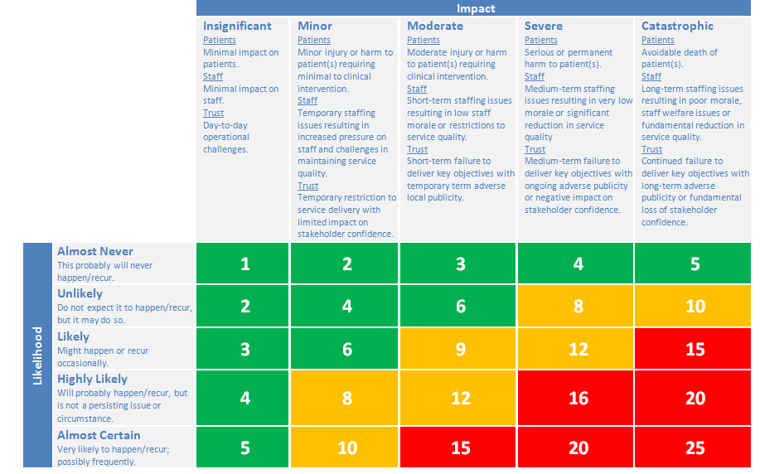

COVID-19 DATA PROTECTION IMPACT ASSESSMENT DECLARATION
Identify the relevant statement listed below and complete boxes
RISK LEVEL | NAME |  |  | DATE
Green/Amber
Red
COVID-19 DATA PROTECTION IMPACT ASSESSMENT SIGN OFF
SIGN OFF |  | DATE |  | PRINT NAME
Senior Responsible Owner (SRO)
DATA PROTECTION IMPACT ASSESSMENT REVIEW
INFORMATION GOVERNANCE REVIEW (NAME) |  |  | DATE

